- Keir Starmer’s resignation means the UK will have a new Prime Minister by September at the latest, with Andy Burnham the clear favourite. Given the UK’s poor fiscal position, perceptions that Burnham might pursue looser fiscal policy, and fading short-end pressures, we expect the yield curve to steepen in the next few months.
- We’re sceptical a new leader will have time to develop a detailed policy platform ready to implement in the autumn budget, particularly given a change of chancellor also looks likely. So we don’t plan any major changes to our baseline forecast in July. We think these developments back our view that the pre-election tightening embedded in the government’s current fiscal plans will be watered down.
Today, Keir Starmer announced he will resign as Labour leader and UK Prime Minister. Nominations to replace him will open on July 9 and close a week later. If there’s a leadership contest, it will take place during the summer recess so that a new leader will be in place by the time parliament returns in early-September.
The process is likely to be concluded quicker. After winning last week’s Makerfield by-election, Andy Burnham will be sworn in as an MP this afternoon, making him eligible to stand in a leadership contest. Former health secretary Wes Streeting, who had previously indicated he would stand in any contest, has thrown his support behind Burnham. Other potential candidates would struggle to attract the support of the 81 MPs needed to get on the ballot paper, so Burnham looks likely to be elected unopposed.
Chart 1: Expectations of tighter monetary policy, not higher term premium, have driven recent rises in gilt yields
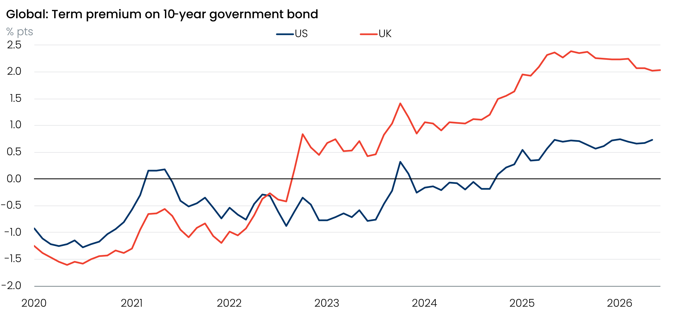
Sources: Oxford Economics modelling using Adrian, Crump, and Moench (2013)

Though our estimates put the term premium at much higher levels in the UK than the US, the UK premium has narrowed a little this year (Chart 1). This suggests that fixed income markets have been focused on the implications of the US-Iran conflict for monetary policy rather than domestic political uncertainty.
We think this situation will now start to change. Last week’s US-Iran agreement has meant short-end pressures have started to fade. Markets are instinctively wary of Burnham because he has advocated costlier left-wing economic and fiscal policies and made critical comments about the role of bond markets. So we expect the long end of the curve to stay elevated, with markets pricing the likelihood of fiscal slippage.
As we argued in a recent note, the next prime minister will inherit a poor fiscal position and a series of structural problems. The UK’s net debt position is weaker than most G7 nations, while countries with much higher levels of debt can take advantage of structural benefits the UK doesn’t share. The UK has one of the highest budget deficits in the G7, and the current plan to reduce borrowing lacks credibility. Meanwhile successive governments have struggled to tackle persistently high inflation and weak productivity growth, with regular political upheaval and increasingly populist discourse making it harder to drive the necessary reforms. As a result, the UK has not yet found a route out of its damaging debt dynamics (Chart 2).
Chart 2: The UK's debt dynamics are weaker than those of most other advanced economies
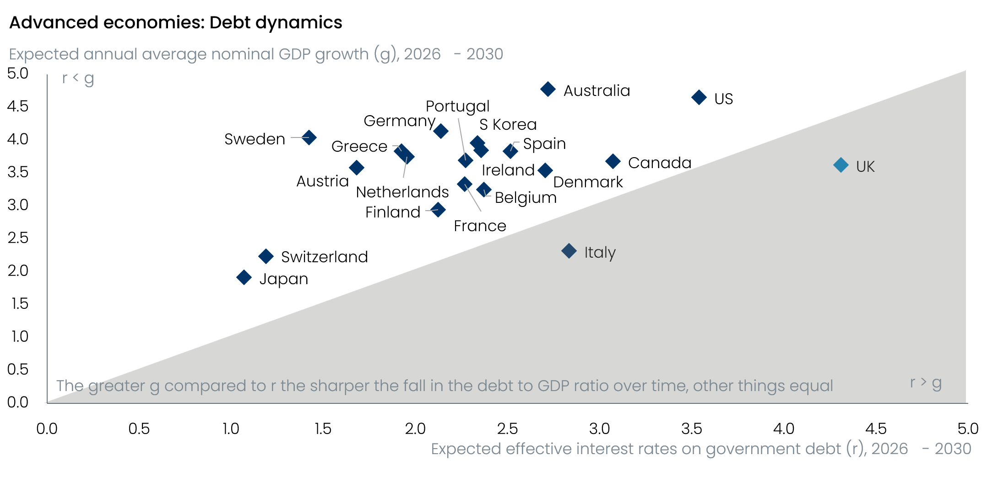
Source: Oxford Economics
Given the pace at which events have unfolded in recent weeks, it’s unlikely that Burnham’s team has a detailed policy package ready to go to tackle these issues. Furthermore, media briefings from his team suggest he plans to replace Rachel Reeves with a new chancellor if he wins the leadership contest. These time constraints plus the need to address concerns about Burnham’s commitment to fiscal sustainability suggest the new administration will avoid implementing major policy changes in this autumn’s Budget.
In the next week or two, we will publish a briefing looking in more detail at Burnham’s likely approach to economic and fiscal policy. But given it will likely take some time for the new leader’s plans to emerge, we don’t plan any major changes to our UK forecasts in July. Our forecasts already assume that the large consolidation planned for 2029 – the year of the next general election – won’t be implemented. In our view, the change of leader means it’s even more likely this tightening is delayed or abandoned.

